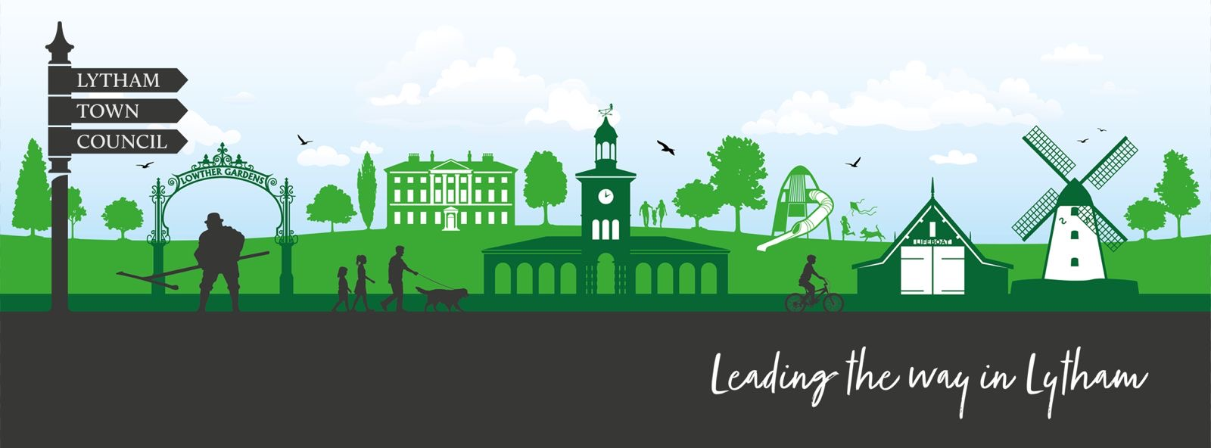
1.Organisation name …………………………………………………………………………………………………………………………………………………………
Phone No: ………………………………………………………………………………………………………………………………….........
Email: ……………………………………………………………………………………………………………………………………………….
…………………………………………………………………………………………………………………………………………………………

2. We are looking to develop a Community Page on our website, would you like a link to your group?
Do you have anyone that deals with media? If so, please give contact details?
…...................................................................................................................................................................
…...................................................................................................................................................................
…………………………………………………………………………………………………………………………………………………………

3. Would it help your group to share or access other groups resources at certain events/occasions? Please describe?

……………………………………………………………………………………………………………………………………………………………………………………
……………………………………………………………………………………………………………………………………………………………………………………
……………………………………………………………………………………………………………………………………………………………………………………

4. We are looking to launch a Community Grant Scheme. What criteria and finance limits would you suggest?

……………………………………………………………………………………………………………………………………………………………………………………
……………………………………………………………………………………………………………………………………………………………………………………
……………………………………………………………………………………………………………………………………………………………………………………
……………………………………………………………………………………………………………………………………………………………………………………
……………………………………………………………………………………………………………………………………………………………………………………
…………………………………………………………………………………………………………………………………………………………………………………..
5. Does your group need help with Finance, More Volunteers, Training, Skills? If so, please add detail?
………………………………………………………………………………………………………………………………………………………………………
……….…………………………………………………………………………………………………………………………………………………………….
………………………………………………………………………………………………………………………………………………………………………
………………………………………………………………………………………………………………………………………………………………………
5a Would you like to encourage younger volunteers? Eg by supporting young schemes Duke of Edinburgh for example?
…………………………………………………………………………………………………………………………………………………………
…………………………………………………………………………………………………………………………………………………………
…………………………………………………………………………………………………………………………………………………………
6. We are planning to formulate a Town Plan for Lytham and we want the Communities feedback would you like to be involved?

……………………………………………………………………………………………………………………………………………………………………………………
……………………………………………………………………………………………………………………………………………………………………………………
……………………………………………………………………………………………………………………………………………………………………………………

7. What Voluntary Groups would benefit Lytham that we don’t yet have?

……………………………………………………………………………………………………………………………………………………………………………………
……………………………………………………………………………………………………………………………………………………………………………………
……………………………………………………………………………………………………………………………………………………………………………………

8. Please add any question or observations you have
……………………………………………………………………………………………………………………………………………………………………………………
……………………………………………………………………………………………………………………………………………………………………………………
.……………………………………………………………………………………………………………………………………………………………………………………
……………………………………………………………………………………………………………………………………………………………………………………
……………………………………………………………………………………………………………………………………………………………………………………
……………………………………………………………………………………………………………………………………………………………………………………
……………………………………………………………………………………………………………………………………………………………………………………
……………………………………………………………………………………………………………………………………………………………………………………
……………………………………………………………………………………………………………………………………………………………………………………
……………………………………………………………………………………………………………………………………………………………………………………
……………………………………………………………………………………………………………………………………………………………………………………
……………………………………………………………………………………………………………………………………………………………………………………

Contact details Clerk@lythamtowncouncil.gov.uk

